Hashing in Data Structure

Introduction to Hashing in Data Structure:
Hashing is a popular technique in computer science that involves mapping large data sets to fixed-length values. It is a process of converting a data set of variable size into a data set of a fixed size. The ability to perform efficient lookup operations makes hashing an essential concept in data structures.

What is Hashing?
A hashing algorithm is used to convert an input (such as a string or integer) into a fixed-size output (referred to as a hash code or hash value). The data is then stored and retrieved using this hash value as an index in an array or hash table. The hash function must be deterministic, which guarantees that it will always yield the same result for a given input.
Hashing is commonly used to create a unique identifier for a piece of data, which can be used to quickly look up that data in a large dataset. For example, a web browser may use hashing to store website passwords securely. When a user enters their password, the browser converts it into a hash value and compares it to the stored hash value to authenticate the user.

What is a hash Key?
In the context of hashing, a hash key (also known as a hash value or hash code) is a fixed-size numerical or alphanumeric representation generated by a hashing algorithm. It is derived from the input data, such as a text string or a file, through a process known as hashing.
Hashing involves applying a specific mathematical function to the input data, which produces a unique hash key that is typically of fixed length, regardless of the size of the input. The resulting hash key is essentially a digital fingerprint of the original data.
The hash key serves several purposes. It is commonly used for data integrity checks, as even a small change in the input data will produce a significantly different hash key. Hash keys are also used for efficient data retrieval and storage in hash tables or data structures, as they allow quick look-up and comparison operations.

How Hashing Works?
The process of hashing can be broken down into three steps:
- Input: The data to be hashed is input into the hashing algorithm.
- Hash Function: The hashing algorithm takes the input data and applies a mathematical function to generate a fixed-size hash value. The hash function should be designed so that different input values produce different hash values, and small changes in the input produce large changes in the output.
- Output: The hash value is returned, which is used as an index to store or retrieve data in a data structure.

Hashing Algorithms:
There are numerous hashing algorithms, each with distinct advantages and disadvantages. The most popular algorithms include the following:
- MD5: A widely used hashing algorithm that produces a 128-bit hash value.
- SHA-1: A popular hashing algorithm that produces a 160-bit hash value.
- SHA-256: A more secure hashing algorithm that produces a 256-bit hash value.
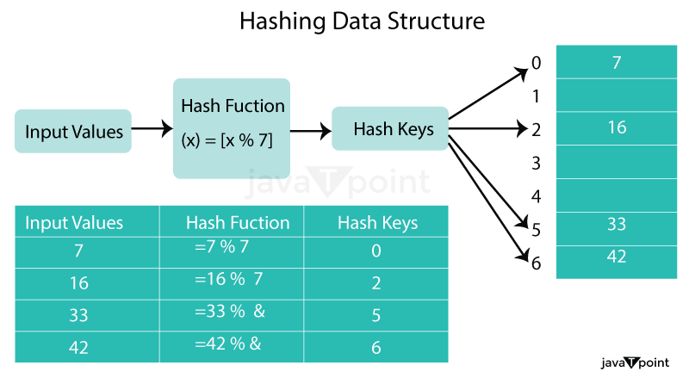

Hash Function:
Hash Function: A hash function is a type of mathematical operation that takes an input (or key) and outputs a fixed-size result known as a hash code or hash value. The hash function must always yield the same hash code for the same input in order to be deterministic. Additionally, the hash function should produce a unique hash code for each input, which is known as the hash property.
There are different types of hash functions, including:
- Division method:
This method involves dividing the key by the table size and taking the remainder as the hash value. For example, if the table size is 10 and the key is 23, the hash value would be 3 (23 % 10 = 3).
- Multiplication method:
This method involves multiplying the key by a constant and taking the fractional part of the product as the hash value. For example, if the key is 23 and the constant is 0.618, the hash value would be 2 (floor(10*(0.61823 - floor(0.61823))) = floor(2.236) = 2).
- Universal hashing:
This method involves using a random hash function from a family of hash functions. This ensures that the hash function is not biased towards any particular input and is resistant to attacks.

Selection Sort Algorithm
In selection sort, the smallest value among the unsorted elements of the array is selected in every pass and inserted to its appropriate position into the array. It is also the simplest algorithm. It is an in-place comparison sorting algorithm. In this algorithm, the array is divided into two parts, first is sorted part, and another one is the unsorted part. Initially, the sorted part of the array is empty, and unsorted part is the given array. Sorted part is placed at the left, while the unsorted part is placed at the right.
In selection sort, the first smallest element is selected from the unsorted array and placed at the first position. After that second smallest element is selected and placed in the second position. The process continues until the array is entirely sorted.
The average and worst-case complexity of selection sort is O(n²), where n is the number of items. Due to this, it is not suitable for large data sets.
Selection sort is generally used when -
- A small array is to be sorted
- Swapping cost doesn't matter
- It is compulsory to check all elements

Algorithm
- SELECTION SORT(arr, n)
- Step 1: Repeat Steps 2 and 3 for i = 0 to n-1
- Step 2: CALL SMALLEST(arr, i, n, pos)
- Step 3: SWAP arr[i] with arr[pos]
- [END OF LOOP]
- Step 4: EXIT
- SMALLEST (arr, i, n, pos)
- Step 1: [INITIALIZE] SET SMALL = arr[i]
- Step 2: [INITIALIZE] SET pos = i
- Step 3: Repeat for j = i+1 to n
- if (SMALL > arr[j])
- SET SMALL = arr[j]
- SET pos = j
- [END OF if]
- [END OF LOOP]
- Step 4: RETURN pos

Working of Selection sort Algorithm
To understand the working of the Selection sort algorithm, let's take an unsorted array. It will be easier to understand the Selection sort via an example.
Let the elements of array are -
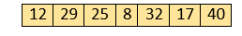
Now, for the first position in the sorted array, the entire array is to be scanned sequentially.
At present, 12 is stored at the first position, after searching the entire array, it is found that 8 is the smallest value.
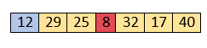
So, swap 12 with 8. After the first iteration, 8 will appear at the first position in the sorted array.
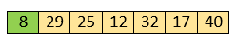
For the second position, where 29 is stored presently, we again sequentially scan the rest of the items of unsorted array. After scanning, we find that 12 is the second lowest element in the array that should be appeared at second position.
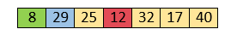
Now, swap 29 with 12. After the second iteration, 12 will appear at the second position in the sorted array. So, after two iterations, the two smallest values are placed at the beginning in a sorted way.
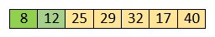
The same process is applied to the rest of the array elements. Now, we are showing a pictorial representation of the entire sorting process.
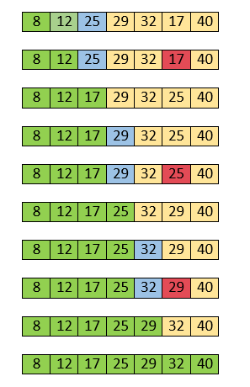
Now, the array is completely sorted.

Selection sort complexity
Now, let's see the time complexity of selection sort in best case, average case, and in worst case. We will also see the space complexity of the selection sort.

1. Time Complexity
Case | Time Complexity
Best Case | O(n²)
Average Case | O(n²)
Worst Case | O(n²)
- Best Case Complexity - It occurs when there is no sorting required, i.e. the array is already sorted. The best-case time complexity of selection sort is O(n²).
- Average Case Complexity - It occurs when the array elements are in jumbled order that is not properly ascending and not properly descending. The average case time complexity of selection sort is O(n²).
- Worst Case Complexity - It occurs when the array elements are required to be sorted in reverse order. That means suppose you have to sort the array elements in ascending order, but its elements are in descending order. The worst-case time complexity of selection sort is O(n²).

2. Space Complexity
Space Complexity | O(1)
Stable | YES
- The space complexity of selection sort is O(1). It is because, in selection sort, an extra variable is required for swapping.

Implementation of selection sort
Now, let's see the programs of selection sort in different programming languages.
Program: Write a program to implement selection sort in C language.
- #include <stdio.h>

- void selection(int arr[], int n)
- {
- int i, j, small;

- for (i = 0; i < n-1; i++) // One by one move boundary of unsorted subarray
- {
- small = i; //minimum element in unsorted array

- for (j = i+1; j < n; j++)
- if (arr[j] < arr[small])
- small = j;
- // Swap the minimum element with the first element
- int temp = arr[small];
- arr[small] = arr[i];
- arr[i] = temp;
- }
- }

- void printArr(int a[], int n) /* function to print the array */
- {
- int i;
- for (i = 0; i < n; i++)
- printf("%d ", a[i]);
- }

- int main()
- {
- int a[] = { 12, 31, 25, 8, 32, 17 };
- int n = sizeof(a) / sizeof(a[0]);
- printf("Before sorting array elements are - \n");
- printArr(a, n);
- selection(a, n);
- printf("\nAfter sorting array elements are - \n");
- printArr(a, n);
- return 0;
- }
Output:
After the execution of above code, the output will be -
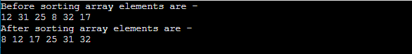

Bubble sort Algorithm
Bubble sort works on the repeatedly swapping of adjacent elements until they are not in the intended order. It is called bubble sort because the movement of array elements is just like the movement of air bubbles in the water. Bubbles in water rise up to the surface; similarly, the array elements in bubble sort move to the end in each iteration.
Although it is simple to use, it is primarily used as an educational tool because the performance of bubble sort is poor in the real world. It is not suitable for large data sets. The average and worst-case complexity of Bubble sort is O(n²), where n is a number of items.
Bubble short is majorly used where -
- complexity does not matter
- simple and shortcode is preferred

Algorithm
In the algorithm given below, suppose arr is an array of n elements. The assumed swap function in the algorithm will swap the values of given array elements.
- begin BubbleSort(arr)
- for all array elements
- if arr[i] > arr[i+1]
- swap(arr[i], arr[i+1])
- end if
- end for
- return arr
- end BubbleSort

Working of Bubble sort Algorithm
Now, let's see the working of Bubble sort Algorithm.
To understand the working of bubble sort algorithm, let's take an unsorted array. We are taking a short and accurate array, as we know the complexity of bubble sort is O(n²).
Let the elements of array are -
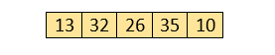

First Pass
Sorting will start from the initial two elements. Let compare them to check which is greater.
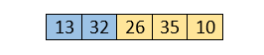
Here, 32 is greater than 13 (32 > 13), so it is already sorted. Now, compare 32 with 26.
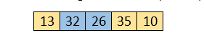
Here, 26 is smaller than 36. So, swapping is required. After swapping new array will look like -
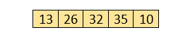
Now, compare 32 and 35.
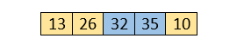
Here, 35 is greater than 32. So, there is no swapping required as they are already sorted.
Now, the comparison will be in between 35 and 10.
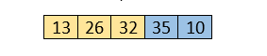
Here, 10 is smaller than 35 that are not sorted. So, swapping is required. Now, we reach at the end of the array. After first pass, the array will be -
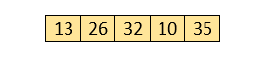
Now, move to the second iteration.

Second Pass
The same process will be followed for second iteration.
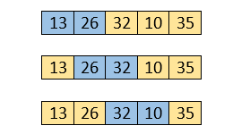
Here, 10 is smaller than 32. So, swapping is required. After swapping, the array will be -
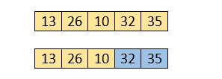
Now, move to the third iteration.

Third Pass
The same process will be followed for third iteration.
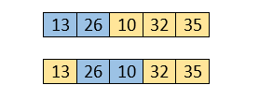
Here, 10 is smaller than 26. So, swapping is required. After swapping, the array will be -
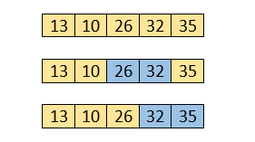
Now, move to the fourth iteration.

Fourth pass
Similarly, after the fourth iteration, the array will be -
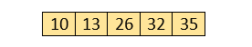
Hence, there is no swapping required, so the array is completely sorted.

Bubble sort complexity
Now, let's see the time complexity of bubble sort in the best case, average case, and worst case. We will also see the space complexity of bubble sort.

1. Time Complexity
Case | Time Complexity
Best Case | O(n)
Average Case | O(n²)
Worst Case | O(n²)
- Best Case Complexity - It occurs when there is no sorting required, i.e. the array is already sorted. The best-case time complexity of bubble sort is O(n).
- Average Case Complexity - It occurs when the array elements are in jumbled order that is not properly ascending and not properly descending. The average case time complexity of bubble sort is O(n²).
- Worst Case Complexity - It occurs when the array elements are required to be sorted in reverse order. That means suppose you have to sort the array elements in ascending order, but its elements are in descending order. The worst-case time complexity of bubble sort is O(n²).

2. Space Complexity
Space Complexity | O(1)
Stable | YES
- The space complexity of bubble sort is O(1). It is because, in bubble sort, an extra variable is required for swapping.
- The space complexity of optimized bubble sort is O(2). It is because two extra variables are required in optimized bubble sort.
Now, let's discuss the optimized bubble sort algorithm.

Optimized Bubble sort Algorithm
In the bubble sort algorithm, comparisons are made even when the array is already sorted. Because of that, the execution time increases.
To solve it, we can use an extra variable swapped. It is set to true if swapping requires; otherwise, it is set to false.
It will be helpful, as suppose after an iteration, if there is no swapping required, the value of variable swapped will be false. It means that the elements are already sorted, and no further iterations are required.
This method will reduce the execution time and also optimizes the bubble sort.

Algorithm for optimized bubble sort
- bubbleSort(array)
- n = length(array)
- repeat
- swapped = false
- for i = 1 to n - 1
- if array[i - 1] > array[i], then
- swap(array[i - 1], array[i])
- swapped = true
- end if
- end for
- n = n - 1
- until not swapped
- end bubbleSort

Implementation of Bubble sort
Now, let's see the programs of Bubble sort in different programming languages.
Program: Write a program to implement bubble sort in C language.
- #include<stdio.h>
- void print(int a[], int n) //function to print array elements
- {
- int i;
- for(i = 0; i < n; i++)
- {
- printf("%d ",a[i]);
- }
- }
- void bubble(int a[], int n) // function to implement bubble sort
- {
- int i, j, temp;
- for(i = 0; i < n; i++)
- {
- for(j = i+1; j < n; j++)
- {
- if(a[j] < a[i])
- {
- temp = a[i];
- a[i] = a[j];
- a[j] = temp;
- }
- }
- }
- }
- void main ()
- {
- int i, j,temp;
- int a[5] = { 10, 35, 32, 13, 26};
- int n = sizeof(a)/sizeof(a[0]);
- printf("Before sorting array elements are - \n");
- print(a, n);
- bubble(a, n);
- printf("\nAfter sorting array elements are - \n");
- print(a, n);
- }
Output
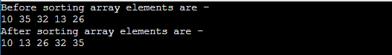

Insertion Sort Algorithm
Insertion sort works similar to the sorting of playing cards in hands. It is assumed that the first card is already sorted in the card game, and then we select an unsorted card. If the selected unsorted card is greater than the first card, it will be placed at the right side; otherwise, it will be placed at the left side. Similarly, all unsorted cards are taken and put in their exact place.
The same approach is applied in insertion sort. The idea behind the insertion sort is that first take one element, iterate it through the sorted array. Although it is simple to use, it is not appropriate for large data sets as the time complexity of insertion sort in the average case and worst case is O(n²), where n is the number of items. Insertion sort is less efficient than the other sorting algorithms like heap sort, quick sort, merge sort, etc.
Insertion sort has various advantages such as -
- Simple implementation
- Efficient for small data sets
- Adaptive, i.e., it is appropriate for data sets that are already substantially sorted.
Now, let's see the algorithm of insertion sort.

Algorithm
The simple steps of achieving the insertion sort are listed as follows -
Step 1 - If the element is the first element, assume that it is already sorted. Return 1.
Step2 - Pick the next element, and store it separately in a key.
Step3 - Now, compare the key with all elements in the sorted array.
Step 4 - If the element in the sorted array is smaller than the current element, then move to the next element. Else, shift greater elements in the array towards the right.
Step 5 - Insert the value.
Step 6 - Repeat until the array is sorted.

Working of Insertion sort Algorithm
Now, let's see the working of the insertion sort Algorithm.
To understand the working of the insertion sort algorithm, let's take an unsorted array. It will be easier to understand the insertion sort via an example.
Let the elements of array are -
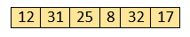
Initially, the first two elements are compared in insertion sort.
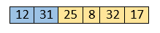
Here, 31 is greater than 12. That means both elements are already in ascending order. So, for now, 12 is stored in a sorted sub-array.
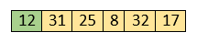
Now, move to the next two elements and compare them.
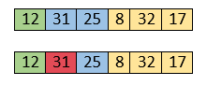
Here, 25 is smaller than 31. So, 31 is not at correct position. Now, swap 31 with 25. Along with swapping, insertion sort will also check it with all elements in the sorted array.
For now, the sorted array has only one element, i.e. 12. So, 25 is greater than 12. Hence, the sorted array remains sorted after swapping.
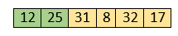
Now, two elements in the sorted array are 12 and 25. Move forward to the next elements that are 31 and 8.
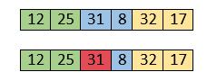
Both 31 and 8 are not sorted. So, swap them.
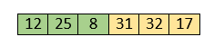
After swapping, elements 25 and 8 are unsorted.
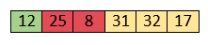
So, swap them.
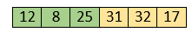
Now, elements 12 and 8 are unsorted.
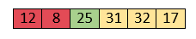
So, swap them too.
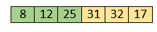
Now, the sorted array has three items that are 8, 12 and 25. Move to the next items that are 31 and 32.
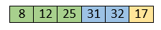
Hence, they are already sorted. Now, the sorted array includes 8, 12, 25 and 31.
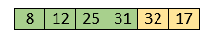
Move to the next elements that are 32 and 17.
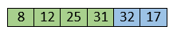
17 is smaller than 32. So, swap them.
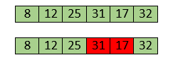
Swapping makes 31 and 17 unsorted. So, swap them too.
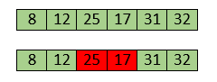
Now, swapping makes 25 and 17 unsorted. So, perform swapping again.
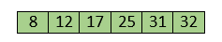
Now, the array is completely sorted.

Insertion sort complexity
Now, let's see the time complexity of insertion sort in best case, average case, and in worst case. We will also see the space complexity of insertion sort.

1. Time Complexity
Case | Time Complexity
Best Case | O(n)
Average Case | O(n²)
Worst Case | O(n²)
- Best Case Complexity - It occurs when there is no sorting required, i.e. the array is already sorted. The best-case time complexity of insertion sort is O(n).
- Average Case Complexity - It occurs when the array elements are in jumbled order that is not properly ascending and not properly descending. The average case time complexity of insertion sort is O(n²).
- Worst Case Complexity - It occurs when the array elements are required to be sorted in reverse order. That means suppose you have to sort the array elements in ascending order, but its elements are in descending order. The worst-case time complexity of insertion sort is O(n²).

2. Space Complexity
Space Complexity | O(1)
Stable | YES
- The space complexity of insertion sort is O(1). It is because, in insertion sort, an extra variable is required for swapping.

Implementation of insertion sort
Now, let's see the programs of insertion sort in different programming languages.
Program: Write a program to implement insertion sort in C language.
- #include <stdio.h>

- void insert(int a[], int n) /* function to sort an aay with insertion sort */
- {
- int i, j, temp;
- for (i = 1; i < n; i++) {
- temp = a[i];
- j = i - 1;

- while(j>=0 && temp <= a[j]) /* Move the elements greater than temp to one position ahead from their current position*/
- {
- a[j+1] = a[j];
- j = j-1;
- }
- a[j+1] = temp;
- }
- }

- void printArr(int a[], int n) /* function to print the array */
- {
- int i;
- for (i = 0; i < n; i++)
- printf("%d ", a[i]);
- }

- int main()
- {
- int a[] = { 12, 31, 25, 8, 32, 17 };
- int n = sizeof(a) / sizeof(a[0]);
- printf("Before sorting array elements are - \n");
- printArr(a, n);
- insert(a, n);
- printf("\nAfter sorting array elements are - \n");
- printArr(a, n);

- return 0;
- }
Output:
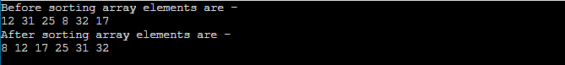

Quick Sort Algorithm
Sorting is a way of arranging items in a systematic manner. Quicksort is the widely used sorting algorithm that makes n log n comparisons in average case for sorting an array of n elements. It is a faster and highly efficient sorting algorithm. This algorithm follows the divide and conquer approach. Divide and conquer is a technique of breaking down the algorithms into subproblems, then solving the subproblems, and combining the results back together to solve the original problem.
Divide: In Divide, first pick a pivot element. After that, partition or rearrange the array into two sub-arrays such that each element in the left sub-array is less than or equal to the pivot element and each element in the right sub-array is larger than the pivot element.
Conquer: Recursively, sort two subarrays with Quicksort.
Combine: Combine the already sorted array.
Quicksort picks an element as pivot, and then it partitions the given array around the picked pivot element. In quick sort, a large array is divided into two arrays in which one holds values that are smaller than the specified value (Pivot), and another array holds the values that are greater than the pivot.
After that, left and right sub-arrays are also partitioned using the same approach. It will continue until the single element remains in the sub-array.
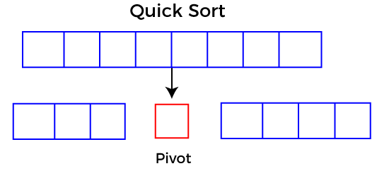

Choosing the pivot
Picking a good pivot is necessary for the fast implementation of quicksort. However, it is typical to determine a good pivot. Some of the ways of choosing a pivot are as follows -
- Pivot can be random, i.e. select the random pivot from the given array.
- Pivot can either be the rightmost element of the leftmost element of the given array.
- Select median as the pivot element.

Algorithm
Algorithm:
- QUICKSORT (array A, start, end)
- {
- 1 if (start < end)
- 2 {
- 3 p = partition(A, start, end)
- 4 QUICKSORT (A, start, p - 1)
- 5 QUICKSORT (A, p + 1, end)
- 6 }
- }
Partition Algorithm:
The partition algorithm rearranges the sub-arrays in a place.
- PARTITION (array A, start, end)
- {
- 1 pivot ? A[end]
- 2 i ? start-1
- 3 for j ? start to end -1 {
- 4 do if (A[j] < pivot) {
- 5 then i ? i + 1
- 6 swap A[i] with A[j]
- 7 }}
- 8 swap A[i+1] with A[end]
- 9 return i+1
- }

Working of Quick Sort Algorithm
Now, let's see the working of the Quicksort Algorithm.
To understand the working of quick sort, let's take an unsorted array. It will make the concept more clear and understandable.
Let the elements of array are -
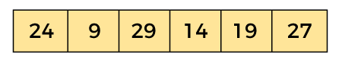
In the given array, we consider the leftmost element as pivot. So, in this case, a[left] = 24, a[right] = 27 and a[pivot] = 24.
Since, pivot is at left, so algorithm starts from right and move towards left.
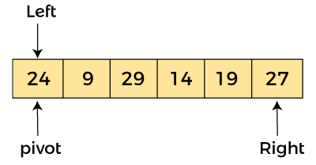
Now, a[pivot] < a[right], so algorithm moves forward one position towards left, i.e. -
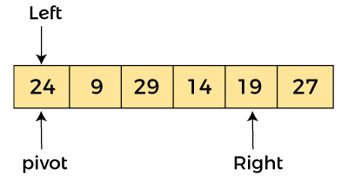
Now, a[left] = 24, a[right] = 19, and a[pivot] = 24.
Because, a[pivot] > a[right], so, algorithm will swap a[pivot] with a[right], and pivot moves to right, as -
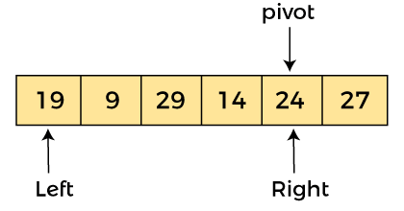
Now, a[left] = 19, a[right] = 24, and a[pivot] = 24. Since, pivot is at right, so algorithm starts from left and moves to right.
As a[pivot] > a[left], so algorithm moves one position to right as -
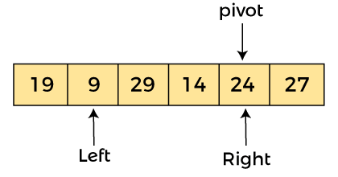
Now, a[left] = 9, a[right] = 24, and a[pivot] = 24. As a[pivot] > a[left], so algorithm moves one position to right as -
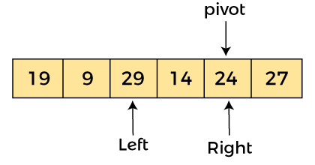
Now, a[left] = 29, a[right] = 24, and a[pivot] = 24. As a[pivot] < a[left], so, swap a[pivot] and a[left], now pivot is at left, i.e. -
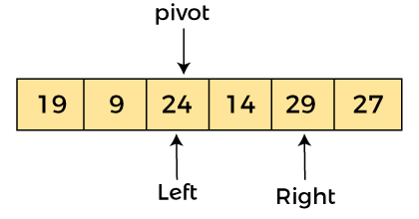
Since, pivot is at left, so algorithm starts from right, and move to left. Now, a[left] = 24, a[right] = 29, and a[pivot] = 24. As a[pivot] < a[right], so algorithm moves one position to left, as -
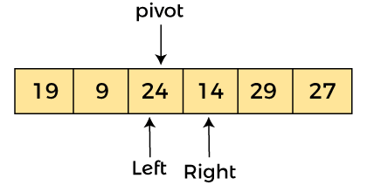
Now, a[pivot] = 24, a[left] = 24, and a[right] = 14. As a[pivot] > a[right], so, swap a[pivot] and a[right], now pivot is at right, i.e. -
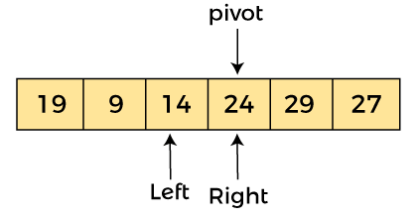
Now, a[pivot] = 24, a[left] = 14, and a[right] = 24. Pivot is at right, so the algorithm starts from left and move to right.
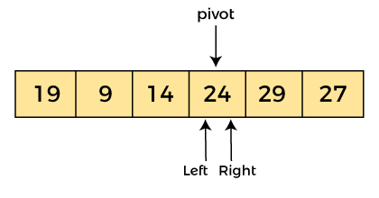
Now, a[pivot] = 24, a[left] = 24, and a[right] = 24. So, pivot, left and right are pointing the same element. It represents the termination of procedure.
Element 24, which is the pivot element is placed at its exact position.
Elements that are right side of element 24 are greater than it, and the elements that are left side of element 24 are smaller than it.
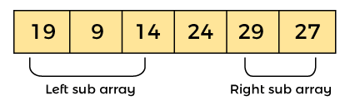
Now, in a similar manner, quick sort algorithm is separately applied to the left and right sub-arrays. After sorting gets done, the array will be -
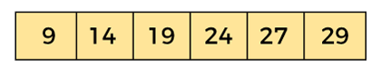

Quicksort complexity
Now, let's see the time complexity of quicksort in best case, average case, and in worst case. We will also see the space complexity of quicksort.

1. Time Complexity
Case | Time Complexity
Best Case | O(n*logn)
Average Case | O(n*logn)
Worst Case | O(n²)
- Best Case Complexity - In Quicksort, the best-case occurs when the pivot element is the middle element or near to the middle element. The best-case time complexity of quicksort is O(n*logn).
- Average Case Complexity - It occurs when the array elements are in jumbled order that is not properly ascending and not properly descending. The average case time complexity of quicksort is O(n*logn).
- Worst Case Complexity - In quick sort, worst case occurs when the pivot element is either greatest or smallest element. Suppose, if the pivot element is always the last element of the array, the worst case would occur when the given array is sorted already in ascending or descending order. The worst-case time complexity of quicksort is O(n²).
Though the worst-case complexity of quicksort is more than other sorting algorithms such as Merge sort and Heap sort, still it is faster in practice. Worst case in quick sort rarely occurs because by changing the choice of pivot, it can be implemented in different ways. Worst case in quicksort can be avoided by choosing the right pivot element.

2. Space Complexity
Space Complexity | O(n*logn)
Stable | NO
- The space complexity of quicksort is O(n*logn).

Implementation of quicksort
Now, let's see the programs of quicksort in different programming languages.
Program: Write a program to implement quicksort in C language.
- #include <stdio.h>
- /* function that consider last element as pivot,
- place the pivot at its exact position, and place
- smaller elements to left of pivot and greater
- elements to right of pivot. */
- int partition (int a[], int start, int end)
- {
- int pivot = a[end]; // pivot element
- int i = (start - 1);

- for (int j = start; j <= end - 1; j++)
- {
- // If current element is smaller than the pivot
- if (a[j] < pivot)
- {
- i++; // increment index of smaller element
- int t = a[i];
- a[i] = a[j];
- a[j] = t;
- }
- }
- int t = a[i+1];
- a[i+1] = a[end];
- a[end] = t;
- return (i + 1);
- }

- /* function to implement quick sort */
- void quick(int a[], int start, int end) /* a[] = array to be sorted, start = Starting index, end = Ending index */
- {
- if (start < end)
- {
- int p = partition(a, start, end); //p is the partitioning index
- quick(a, start, p - 1);
- quick(a, p + 1, end);
- }
- }

- /* function to print an array */
- void printArr(int a[], int n)
- {
- int i;
- for (i = 0; i < n; i++)
- printf("%d ", a[i]);
- }
- int main()
- {
- int a[] = { 24, 9, 29, 14, 19, 27 };
- int n = sizeof(a) / sizeof(a[0]);
- printf("Before sorting array elements are - \n");
- printArr(a, n);
- quick(a, 0, n - 1);
- printf("\nAfter sorting array elements are - \n");
- printArr(a, n);

- return 0;
- }
Output:
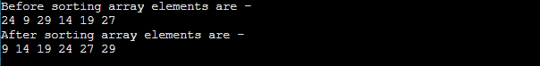

Merge Sort Algorithm
Merge sort is similar to the quick sort algorithm as it uses the divide and conquer approach to sort the elements. It is one of the most popular and efficient sorting algorithm. It divides the given list into two equal halves, calls itself for the two halves and then merges the two sorted halves. We have to define the merge() function to perform the merging.
The sub-lists are divided again and again into halves until the list cannot be divided further. Then we combine the pair of one element lists into two-element lists, sorting them in the process. The sorted two-element pairs is merged into the four-element lists, and so on until we get the sorted list.
Now, let's see the algorithm of merge sort.

Algorithm
In the following algorithm, arr is the given array, beg is the starting element, and end is the last element of the array.
- MERGE_SORT(arr, beg, end)

- if beg < end
- set mid = (beg + end)/2
- MERGE_SORT(arr, beg, mid)
- MERGE_SORT(arr, mid + 1, end)
- MERGE (arr, beg, mid, end)
- end of if

- END MERGE_SORT
The important part of the merge sort is the MERGE function. This function performs the merging of two sorted sub-arrays that are A[beg…mid] and A[mid+1…end], to build one sorted array A[beg…end]. So, the inputs of the MERGE function are A[], beg, mid, and end.
The implementation of the MERGE function is given as follows -
- /* Function to merge the subarrays of a[] */
- void merge(int a[], int beg, int mid, int end)
- {
- int i, j, k;
- int n1 = mid - beg + 1;
- int n2 = end - mid;

- int LeftArray[n1], RightArray[n2]; //temporary arrays

- /* copy data to temp arrays */
- for (int i = 0; i < n1; i++)
- LeftArray[i] = a[beg + i];
- for (int j = 0; j < n2; j++)
- RightArray[j] = a[mid + 1 + j];

- i = 0, /* initial index of first sub-array */
- j = 0; /* initial index of second sub-array */
- k = beg; /* initial index of merged sub-array */

- while (i < n1 && j < n2)
- {
- if(LeftArray[i] <= RightArray[j])
- {
- a[k] = LeftArray[i];
- i++;
- }
- else
- {
- a[k] = RightArray[j];
- j++;
- }
- k++;
- }
- while (i<n1)
- {
- a[k] = LeftArray[i];
- i++;
- k++;
- }

- while (j<n2)
- {
- a[k] = RightArray[j];
- j++;
- k++;
- }
- }

Working of Merge sort Algorithm
Now, let's see the working of merge sort Algorithm.
To understand the working of the merge sort algorithm, let's take an unsorted array. It will be easier to understand the merge sort via an example.
Let the elements of array are -
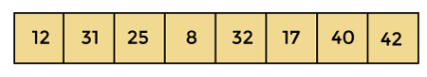
According to the merge sort, first divide the given array into two equal halves. Merge sort keeps dividing the list into equal parts until it cannot be further divided.
As there are eight elements in the given array, so it is divided into two arrays of size 4.
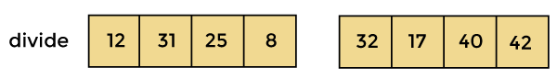
Now, again divide these two arrays into halves. As they are of size 4, so divide them into new arrays of size 2.
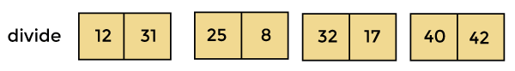
Now, again divide these arrays to get the atomic value that cannot be further divided.
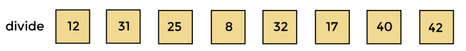
Now, combine them in the same manner they were broken.
In combining, first compare the element of each array and then combine them into another array in sorted order.
So, first compare 12 and 31, both are in sorted positions. Then compare 25 and 8, and in the list of two values, put 8 first followed by 25. Then compare 32 and 17, sort them and put 17 first followed by 32. After that, compare 40 and 42, and place them sequentially.
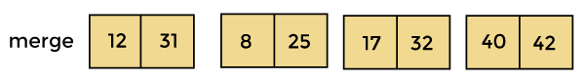
In the next iteration of combining, now compare the arrays with two data values and merge them into an array of found values in sorted order.
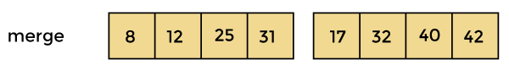
Now, there is a final merging of the arrays. After the final merging of above arrays, the array will look like -
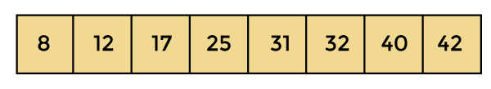
Now, the array is completely sorted.

Merge sort complexity
Now, let's see the time complexity of merge sort in best case, average case, and in worst case. We will also see the space complexity of the merge sort.

1. Time Complexity
Case | Time Complexity
Best Case | O(n*logn)
Average Case | O(n*logn)
Worst Case | O(n*logn)
- Best Case Complexity - It occurs when there is no sorting required, i.e. the array is already sorted. The best-case time complexity of merge sort is O(n*logn).
- Average Case Complexity - It occurs when the array elements are in jumbled order that is not properly ascending and not properly descending. The average case time complexity of merge sort is O(n*logn).
- Worst Case Complexity - It occurs when the array elements are required to be sorted in reverse order. That means suppose you have to sort the array elements in ascending order, but its elements are in descending order. The worst-case time complexity of merge sort is O(n*logn).

2. Space Complexity
Space Complexity | O(n)
Stable | YES
- The space complexity of merge sort is O(n). It is because, in merge sort, an extra variable is required for swapping.

Implementation of merge sort
Now, let's see the programs of merge sort in different programming languages.
Program: Write a program to implement merge sort in C language.
- #include <stdio.h>

- /* Function to merge the subarrays of a[] */
- void merge(int a[], int beg, int mid, int end)
- {
- int i, j, k;
- int n1 = mid - beg + 1;
- int n2 = end - mid;

- int LeftArray[n1], RightArray[n2]; //temporary arrays

- /* copy data to temp arrays */
- for (int i = 0; i < n1; i++)
- LeftArray[i] = a[beg + i];
- for (int j = 0; j < n2; j++)
- RightArray[j] = a[mid + 1 + j];

- i = 0; /* initial index of first sub-array */
- j = 0; /* initial index of second sub-array */
- k = beg; /* initial index of merged sub-array */

- while (i < n1 && j < n2)
- {
- if(LeftArray[i] <= RightArray[j])
- {
- a[k] = LeftArray[i];
- i++;
- }
- else
- {
- a[k] = RightArray[j];
- j++;
- }
- k++;
- }
- while (i<n1)
- {
- a[k] = LeftArray[i];
- i++;
- k++;
- }

- while (j<n2)
- {
- a[k] = RightArray[j];
- j++;
- k++;
- }
- }

- void mergeSort(int a[], int beg, int end)
- {
- if (beg < end)
- {
- int mid = (beg + end) / 2;
- mergeSort(a, beg, mid);
- mergeSort(a, mid + 1, end);
- merge(a, beg, mid, end);
- }
- }

- /* Function to print the array */
- void printArray(int a[], int n)
- {
- int i;
- for (i = 0; i < n; i++)
- printf("%d ", a[i]);
- printf("\n");
- }

- int main()
- {
- int a[] = { 12, 31, 25, 8, 32, 17, 40, 42 };
- int n = sizeof(a) / sizeof(a[0]);
- printf("Before sorting array elements are - \n");
- printArray(a, n);
- mergeSort(a, 0, n - 1);
- printf("After sorting array elements are - \n");
- printArray(a, n);
- return 0;
- }
Output:
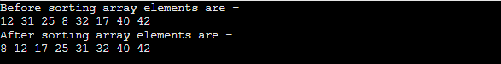

Heap Sort Algorithm
Heap sort processes the elements by creating the min-heap or max-heap using the elements of the given array. Min-heap or max-heap represents the ordering of array in which the root element represents the minimum or maximum element of the array.
Heap sort basically recursively performs two main operations -
- Build a heap H, using the elements of array.
- Repeatedly delete the root element of the heap formed in 1st phase.
Before knowing more about the heap sort, let's first see a brief description of Heap.

What is a heap?
A heap is a complete binary tree, and the binary tree is a tree in which the node can have the utmost two children. A complete binary tree is a binary tree in which all the levels except the last level, i.e., leaf node, should be completely filled, and all the nodes should be left-justified.

What is heap sort?
Heapsort is a popular and efficient sorting algorithm. The concept of heap sort is to eliminate the elements one by one from the heap part of the list, and then insert them into the sorted part of the list.
Heapsort is the in-place sorting algorithm.
Now, let's see the algorithm of heap sort.

Algorithm
- HeapSort(arr)
- BuildMaxHeap(arr)
- for i = length(arr) to 2
- swap arr[1] with arr[i]
- heap_size[arr] = heap_size[arr] ? 1
- MaxHeapify(arr,1)
- End
BuildMaxHeap(arr)
- BuildMaxHeap(arr)
- heap_size(arr) = length(arr)
- for i = length(arr)/2 to 1
- MaxHeapify(arr,i)
- End
MaxHeapify(arr,i)
- MaxHeapify(arr,i)
- L = left(i)
- R = right(i)
- if L ? heap_size[arr] and arr[L] > arr[i]
- largest = L
- else
- largest = i
- if R ? heap_size[arr] and arr[R] > arr[largest]
- largest = R
- if largest != i
- swap arr[i] with arr[largest]
- MaxHeapify(arr,largest)
- End

Working of Heap sort Algorithm
Now, let's see the working of the Heapsort Algorithm.
In heap sort, basically, there are two phases involved in the sorting of elements. By using the heap sort algorithm, they are as follows -
- The first step includes the creation of a heap by adjusting the elements of the array.
- After the creation of heap, now remove the root element of the heap repeatedly by shifting it to the end of the array, and then store the heap structure with the remaining elements.
Now let's see the working of heap sort in detail by using an example. To understand it more clearly, let's take an unsorted array and try to sort it using heap sort. It will make the explanation clearer and easier.
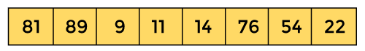
First, we have to construct a heap from the given array and convert it into max heap.
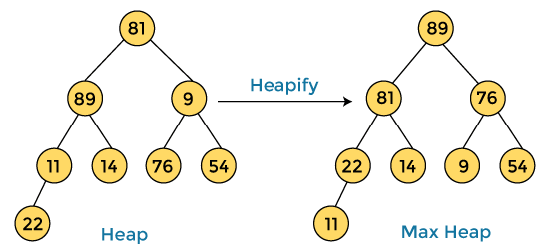
After converting the given heap into max heap, the array elements are -
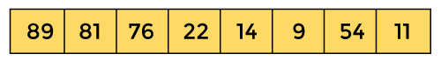
Next, we have to delete the root element (89) from the max heap. To delete this node, we have to swap it with the last node, i.e. (11). After deleting the root element, we again have to heapify it to convert it into max heap.
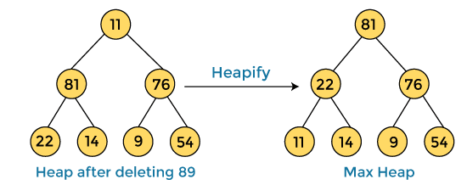
After swapping the array element 89 with 11, and converting the heap into max-heap, the elements of array are -
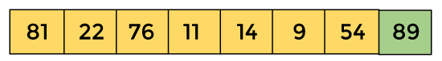
In the next step, again, we have to delete the root element (81) from the max heap. To delete this node, we have to swap it with the last node, i.e. (54). After deleting the root element, we again have to heapify it to convert it into max heap.
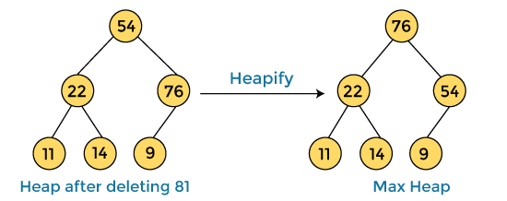
After swapping the array element 81 with 54 and converting the heap into max-heap, the elements of array are -
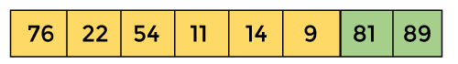
In the next step, we have to delete the root element (76) from the max heap again. To delete this node, we have to swap it with the last node, i.e. (9). After deleting the root element, we again have to heapify it to convert it into max heap.
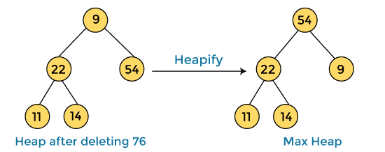
After swapping the array element 76 with 9 and converting the heap into max-heap, the elements of array are -
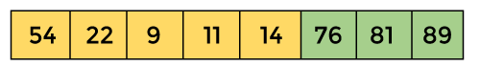
In the next step, again we have to delete the root element (54) from the max heap. To delete this node, we have to swap it with the last node, i.e. (14). After deleting the root element, we again have to heapify it to convert it into max heap.
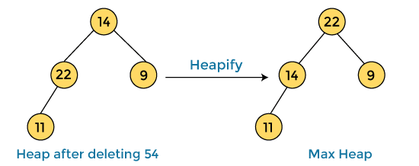
After swapping the array element 54 with 14 and converting the heap into max-heap, the elements of array are -
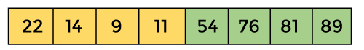
In the next step, again we have to delete the root element (22) from the max heap. To delete this node, we have to swap it with the last node, i.e. (11). After deleting the root element, we again have to heapify it to convert it into max heap.
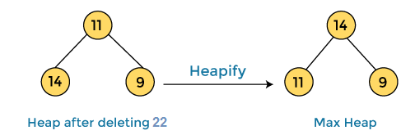
After swapping the array element 22 with 11 and converting the heap into max-heap, the elements of array are -
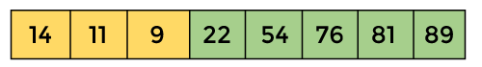
In the next step, again we have to delete the root element (14) from the max heap. To delete this node, we have to swap it with the last node, i.e. (9). After deleting the root element, we again have to heapify it to convert it into max heap.
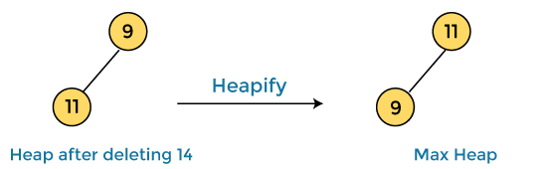
After swapping the array element 14 with 9 and converting the heap into max-heap, the elements of array are -
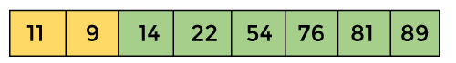
In the next step, again we have to delete the root element (11) from the max heap. To delete this node, we have to swap it with the last node, i.e. (9). After deleting the root element, we again have to heapify it to convert it into max heap.

After swapping the array element 11 with 9, the elements of array are -
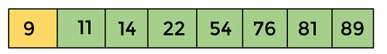
Now, heap has only one element left. After deleting it, heap will be empty.
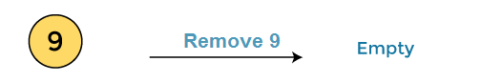
After completion of sorting, the array elements are -
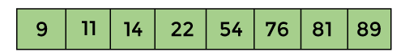
Now, the array is completely sorted.

Heap sort complexity
Now, let's see the time complexity of Heap sort in the best case, average case, and worst case. We will also see the space complexity of Heapsort.

1. Time Complexity
Case | Time Complexity
Best Case | O(n logn)
Average Case | O(n log n)
Worst Case | O(n log n)
- Best Case Complexity - It occurs when there is no sorting required, i.e. the array is already sorted. The best-case time complexity of heap sort is O(n logn).
- Average Case Complexity - It occurs when the array elements are in jumbled order that is not properly ascending and not properly descending. The average case time complexity of heap sort is O(n log n).
- Worst Case Complexity - It occurs when the array elements are required to be sorted in reverse order. That means suppose you have to sort the array elements in ascending order, but its elements are in descending order. The worst-case time complexity of heap sort is O(n log n).
The time complexity of heap sort is O(n logn) in all three cases (best case, average case, and worst case). The height of a complete binary tree having n elements is logn.

2. Space Complexity
Space Complexity | O(1)
Stable | N0
- The space complexity of Heap sort is O(1).

Implementation of Heapsort
Now, let's see the programs of Heap sort in different programming languages.
Program: Write a program to implement heap sort in C language.
- #include <stdio.h>
- /* function to heapify a subtree. Here 'i' is the
- index of root node in array a[], and 'n' is the size of heap. */
- void heapify(int a[], int n, int i)
- {
- int largest = i; // Initialize largest as root
- int left = 2 * i + 1; // left child
- int right = 2 * i + 2; // right child
- // If left child is larger than root
- if (left < n && a[left] > a[largest])
- largest = left;
- // If right child is larger than root
- if (right < n && a[right] > a[largest])
- largest = right;
- // If root is not largest
- if (largest != i) {
- // swap a[i] with a[largest]
- int temp = a[i];
- a[i] = a[largest];
- a[largest] = temp;

- heapify(a, n, largest);
- }
- }
- /*Function to implement the heap sort*/
- void heapSort(int a[], int n)
- {
- for (int i = n / 2 - 1; i >= 0; i--)
- heapify(a, n, i);
- // One by one extract an element from heap
- for (int i = n - 1; i >= 0; i--) {
- /* Move current root element to end*/
- // swap a[0] with a[i]
- int temp = a[0];
- a[0] = a[i];
- a[i] = temp;

- heapify(a, i, 0);
- }
- }
- /* function to print the array elements */
- void printArr(int arr[], int n)
- {
- for (int i = 0; i < n; ++i)
- {
- printf("%d", arr[i]);
- printf(" ");
- }

- }
- int main()
- {
- int a[] = {48, 10, 23, 43, 28, 26, 1};
- int n = sizeof(a) / sizeof(a[0]);
- printf("Before sorting array elements are - \n");
- printArr(a, n);
- heapSort(a, n);
- printf("\nAfter sorting array elements are - \n");
- printArr(a, n);
- return 0;
- }
Output
